The Top 12 Pay Per Click Advertising Affiliate Program Platforms For 2026
Discover the best pay per click advertising affiliate program platforms to scale your campaigns. Our guide covers pros, cons, policies, and tracking tips.
Published on Jan 22, 2026
Arthur Dent
AliasLinks Editor
Table of Contents
- 1. Google Ads
- Key Features and Considerations
- 2. Microsoft Advertising
- Key Features and Considerations
- 3. TikTok Ads
- Key Features and Considerations
- 4. Taboola
- Key Features and Considerations
- 5. Outbrain
- Key Features and Considerations
- 6. MGID
- Key Features and Considerations
- 7. Revcontent
- Key Features and Considerations
- 8. Media.net
- Key Features and Considerations
- 9. PropellerAds
- Key Features and Considerations
- 10. Adsterra
- Key Features and Considerations
- 11. Zeropark
- Key Features and Considerations
- 12. BidVertiser
- Key Features and Considerations
- Top 12 PPC Affiliate Networks Comparison
- Final Verdict: Choosing Your Next PPC Platform
- Matching the Platform to Your Purpose
- The Strategic Blueprint for Success

- Twitter
- Facebook
- LinkedIn
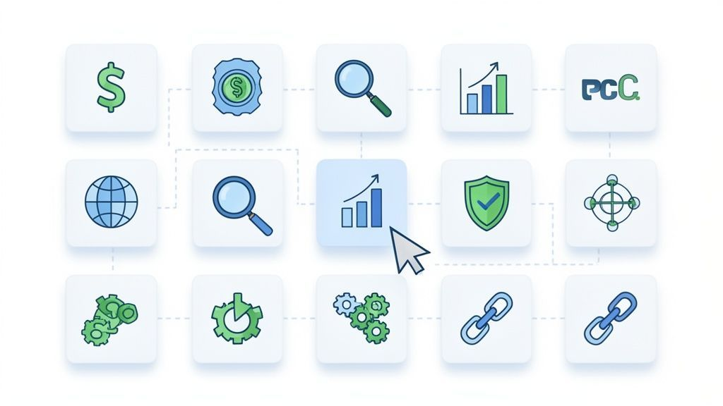
Welcome to your definitive guide on leveraging the most powerful pay-per-click advertising platforms for affiliates. Success in this field hinges on finding the right traffic source, one that skillfully balances cost, quality, and scale. Navigating the world of PPC can be daunting, with a complex web of varying policies, bidding models, and compliance rules that can make or break a campaign before it even starts.
This resource is designed to cut through that noise. We will dive deep into the top 12 platforms, analyzing not just their surface-level features, but the practical nuances that truly matter to affiliate marketers. We’ll explore strictness on direct linking, minimum deposit requirements, and which types of offers thrive on each network. This guide provides a clear roadmap, helping you avoid costly mistakes and identify the most profitable traffic sources for your specific niche. To further assist in identifying suitable tools and programs, you can explore detailed tips for finding the best affiliate marketing platform.
We will also cover essential strategies for campaign survival and optimization, including tracking and link management. You'll learn why tools like link cloakers are non-negotiable for protecting your campaigns on sensitive platforms like TikTok and Facebook Ads. Whether you're a seasoned media buyer looking for a new traffic source or just starting your journey with a pay per click advertising affiliate program, this curated list will equip you with the actionable insights needed to choose the right partner, optimize your ad spend, and drive sustainable affiliate revenue. Each platform review includes screenshots and direct links to help you get started immediately.

1. Google Ads
As the world's largest pay-per-click advertising platform, Google Ads is an essential starting point for any affiliate marketer serious about PPC. Its primary strength lies in capturing high-intent traffic directly from Google Search, reaching users at the exact moment they are looking for a solution. This makes it an indispensable tool for promoting affiliate offers in nearly every vertical, from e-commerce products to B2B software.
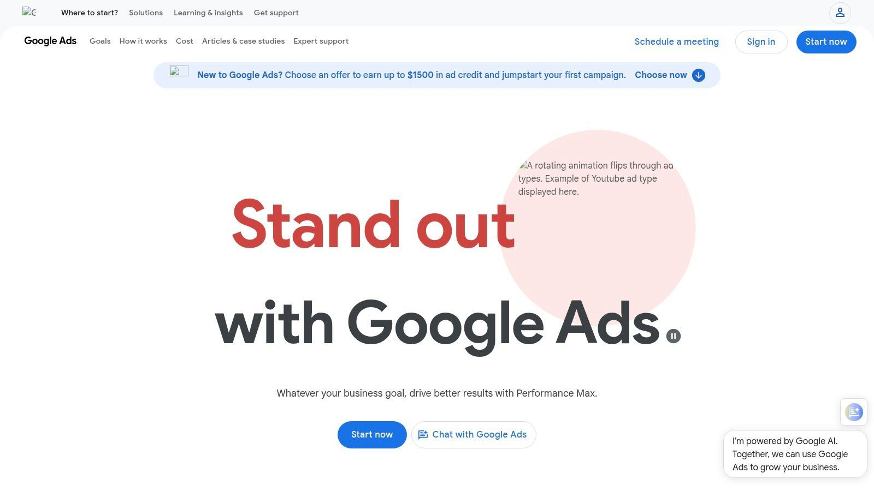
The platform offers unparalleled reach across Search, YouTube, and the Display Network, all managed from a single dashboard. For affiliates, this means you can test different ad formats and audience strategies efficiently. For instance, you could run a highly targeted search campaign for immediate conversions while simultaneously running a YouTube campaign to build brand awareness for a long-term affiliate partnership. If you want to dive deeper into strategy, you can explore our comprehensive guide on pay per click affiliate marketing.

Key Features and Considerations
- Campaign Types: Supports Search, Shopping, Display, Video (YouTube), and Performance Max campaigns, providing flexibility for diverse affiliate offers.
- Targeting: Granular control over keywords, demographics, locations, and audiences (including remarketing lists) allows for precise campaign focus.
- Bidding: Mature "Smart Bidding" algorithms can automate bid adjustments to maximize conversions or conversion value, which is crucial for optimizing affiliate ROI.
Website: https://ads.google.com

2. Microsoft Advertising
Often viewed as the essential alternative to Google, Microsoft Advertising (formerly Bing Ads) is a powerful pay-per-click platform that should not be overlooked by affiliate marketers. Its core strength comes from serving ads on the Microsoft Search Network, which includes Bing, Yahoo, and AOL, capturing a mature and often high-income audience. This makes it an excellent platform for affiliates in B2B, finance, and other professional service verticals.
The platform provides a significant advantage with its generally lower competition and cost-per-click (CPC) compared to Google Ads. For affiliates, this translates to a potentially higher ROI, especially in crowded markets. Microsoft also makes it incredibly easy to get started by offering a tool to import existing campaigns directly from Google Ads. Proper setup is critical here, so be sure to understand how to track affiliate links to ensure your imported campaigns report data correctly.

Key Features and Considerations
- Campaign Types: Supports Search, Shopping, and Audience Network campaigns, which serve responsive ads on high-quality native placements.
- Targeting: Offers unique LinkedIn Profile Targeting (in some markets), allowing for precise B2B audience segmentation based on company, job function, and industry.
- Support: Known for its accessible and helpful U.S.-based support options, including phone and chat, which can be a lifeline for affiliates navigating policy questions.
Website: https://ads.microsoft.com

3. TikTok Ads
TikTok Ads has rapidly emerged as a powerhouse for affiliate marketers looking to tap into a highly engaged, younger demographic. Its strength lies in its visually-driven, short-form video format, making it ideal for direct-to-consumer (DTC) products, mobile apps, and social commerce offers. The platform's algorithm is exceptionally skilled at discovering and serving content to interested users, allowing affiliate campaigns to gain viral traction and drive traffic at potentially lower costs than more established platforms.
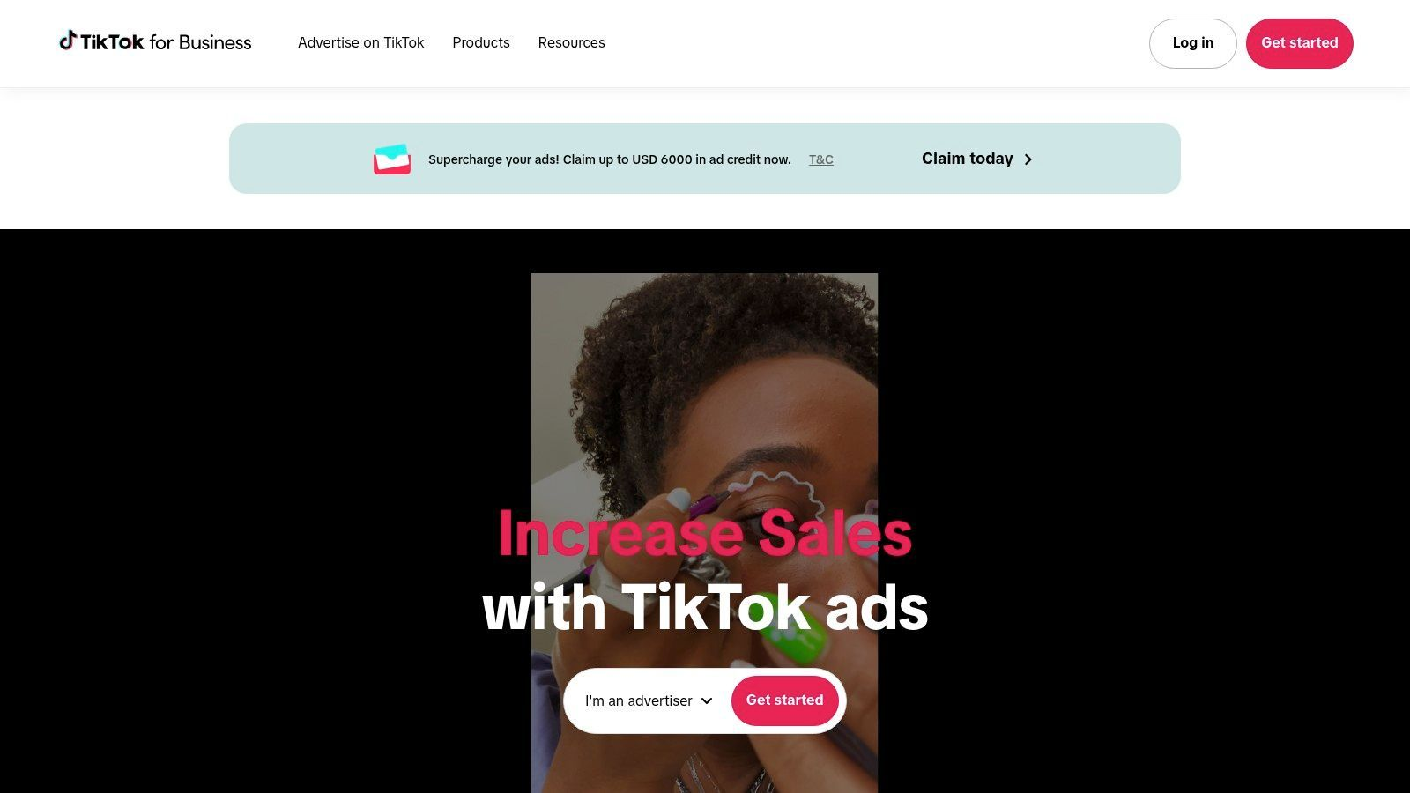
The platform is designed for rapid creative testing, enabling affiliates to quickly iterate on ad concepts to find winning combinations. With objectives like Traffic and Conversions, you can tailor campaigns to your specific affiliate goals, whether it's lead generation or direct sales. For a deeper look into maximizing your results, explore our complete guide to TikTok advertising. This makes it a compelling pay per click advertising affiliate program choice for agile marketers.

Key Features and Considerations
- Campaign Objectives: Supports a range of goals including Traffic, Conversions, and App Installs, which are directly applicable to common affiliate marketing models.
- Creative Tools: Offers robust in-app video editing tools and access to a commercial music library, lowering the barrier to entry for creating compelling video ads.
- Targeting: Provides broad interest and behavior targeting, along with powerful lookalike audience capabilities to scale successful campaigns.
Website: https://ads.tiktok.com

4. Taboola
As a leading native content discovery network, Taboola offers a distinct approach for affiliates looking to move beyond traditional search. Its primary strength is placing sponsored content on premium publisher websites like USA Today and Business Insider, reaching users while they are actively consuming news and articles. This makes it an ideal platform for top-of-funnel affiliate strategies, particularly those using advertorials or listicles to warm up traffic before sending it to an offer.
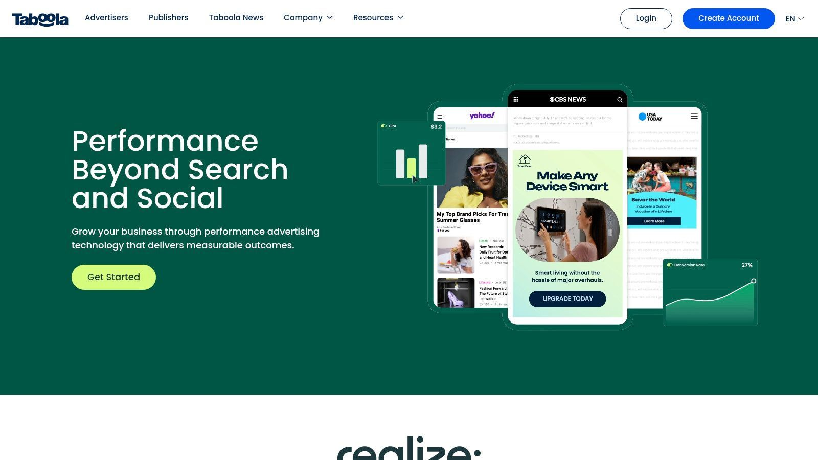
Taboola’s model thrives on curiosity-driven clicks rather than direct search intent, requiring a different creative mindset. Successful affiliates build multi-step funnels, often using a pre-lander to bridge the gap between the publisher's article and the affiliate offer. This platform is a powerful part of a pay per click advertising affiliate program for those who can craft compelling narratives. Because native ads can have unique tracking requirements, affiliates often use tools to manage their campaigns; you can explore the benefits of link cloaking to better protect your native ad funnels.

Key Features and Considerations
- Bidding Model: Primarily operates on a CPC (Cost-Per-Click) model, allowing affiliates to control ad spend on a per-click basis with automated or threshold-based billing.
- Publisher Network: Access to a vast network of high-authority news and lifestyle websites, powered by an AI-based recommendation engine to match content with interested audiences.
- Creative Controls: Provides robust options for managing creatives, placements, and brand safety settings to ensure ads appear in suitable contexts.
Website: https://www.taboola.com

5. Outbrain
Outbrain stands out as a premium native advertising platform, providing affiliates with access to high-quality publisher inventory on major news and media sites. Similar to Taboola, it specializes in placing content-style ads within editorial feeds, making it an excellent choice for promotions that benefit from a softer, more informational approach. Affiliates can leverage this to drive traffic to pre-landers, advertorials, or detailed product reviews that warm up audiences before presenting an offer.
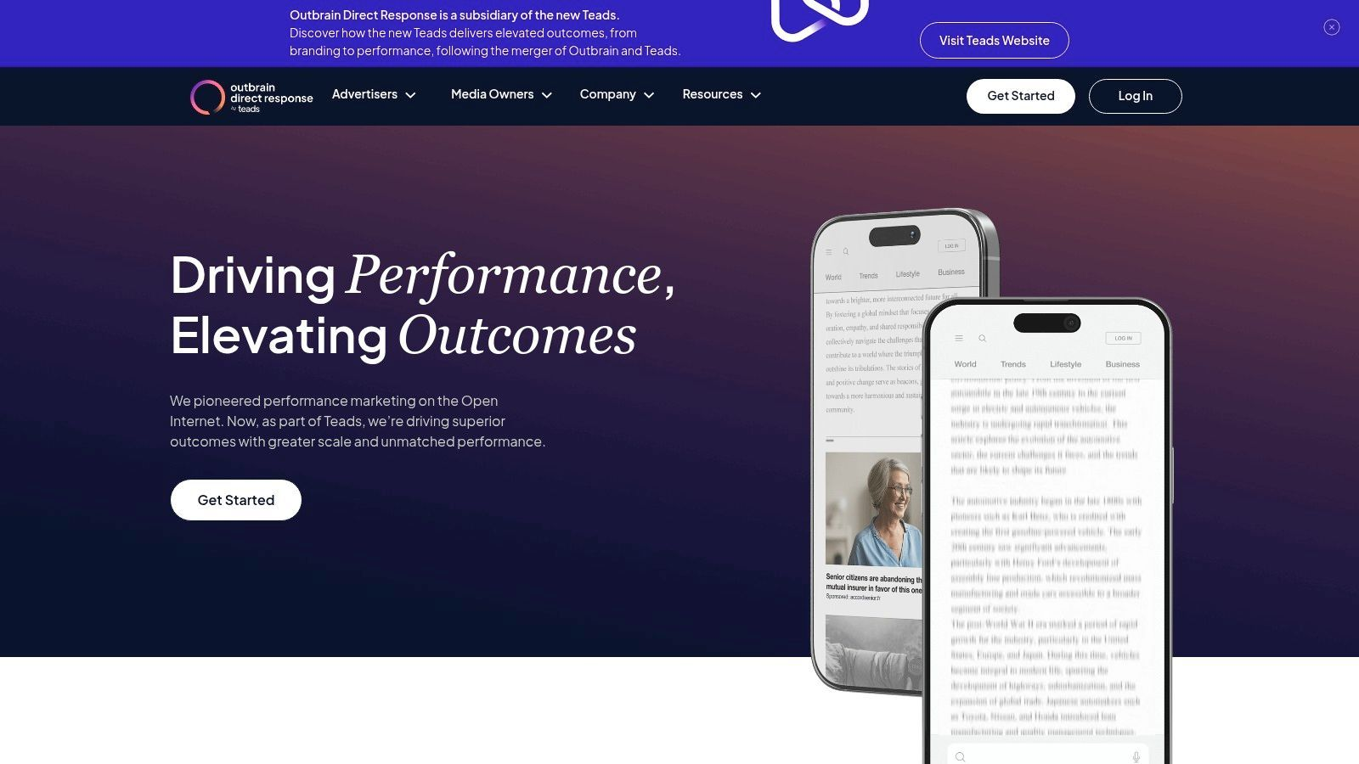
The platform is particularly strong for those running campaigns in the U.S. due to its extensive list of premium domestic publishers. Outbrain’s strength for affiliates lies in its granular control over bidding and placements. You can fine-tune your cost-per-click (CPC) bids based on the publisher section, time of day, and even the hour, allowing for meticulous optimization of your advertising spend. This level of control is crucial for maximizing ROI in any pay per click advertising affiliate program.

Key Features and Considerations
- Bidding Controls: Offers CPC pricing with highly specific adjustments, including day/hour parting and section-level CPC modifications to target the most profitable traffic segments.
- Automated Optimization: Features conversion-based bidding algorithms and automated testing tools to help streamline campaign management and improve performance.
- Placement Targeting: Provides detailed publisher-section controls, giving affiliates the power to exclude poor-performing placements and double down on successful ones.
Website: https://www.outbrain.com

6. MGID
MGID stands out as a leading native advertising platform that gives affiliate marketers an alternative to traditional search and social PPC. Its strength lies in placing ads that blend seamlessly with publisher content, capturing user attention in a less intrusive way. This makes it an excellent choice for promoting content-based funnels, lead generation offers, and e-commerce products where discovery, not just direct intent, drives conversions.
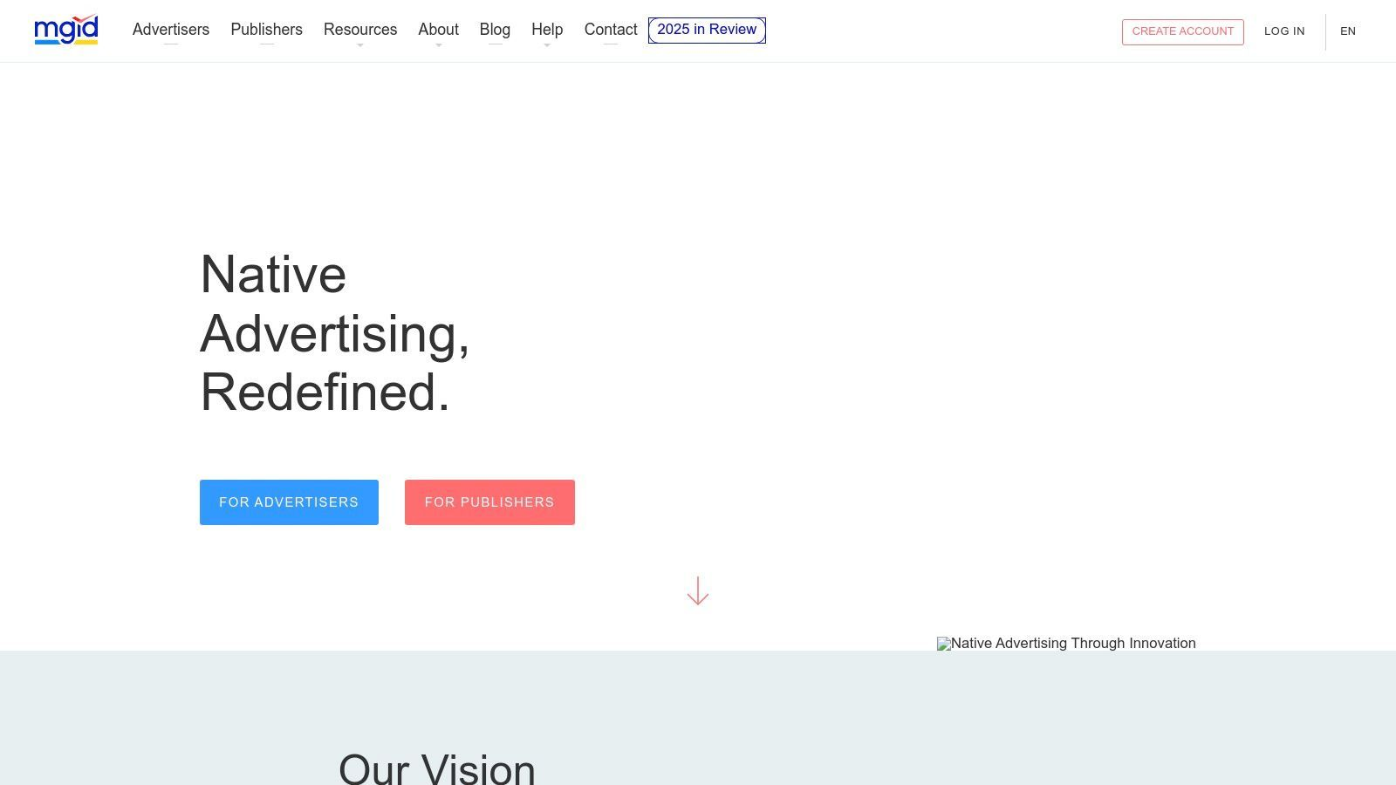
The self-serve platform allows affiliates to get started quickly, often with new advertiser deposit promotions that lower the barrier to entry. With its global reach, you can test offers in various GEOs that might be too competitive or expensive on other networks. For those in the pay per click advertising affiliate program space, MGID provides a scalable way to drive traffic to presell pages or articles before sending users to the final affiliate offer, warming up the audience for better conversion rates.

Key Features and Considerations
- Bidding Model: Primarily operates on a Cost-Per-Click (CPC) basis, which can be set at the campaign or individual ad level, with helpful CPC range suggestions.
- Platform Accessibility: A user-friendly, self-serve platform makes campaign setup and management straightforward for affiliates of all experience levels.
- Targeting Options: Offers comprehensive targeting by GEO, device, browser, language, and carrier, allowing for precise audience segmentation.
Website: https://www.mgid.com

7. Revcontent
Revcontent is a leading content recommendation and native advertising network that provides a valuable source of traffic for performance-driven affiliates. It specializes in placing sponsored content within publisher widgets, appearing as "recommended articles" on popular news and content websites. This format allows affiliates to capture user attention in a less disruptive way than traditional banner ads, making it an effective platform for lead generation and content-based offers.
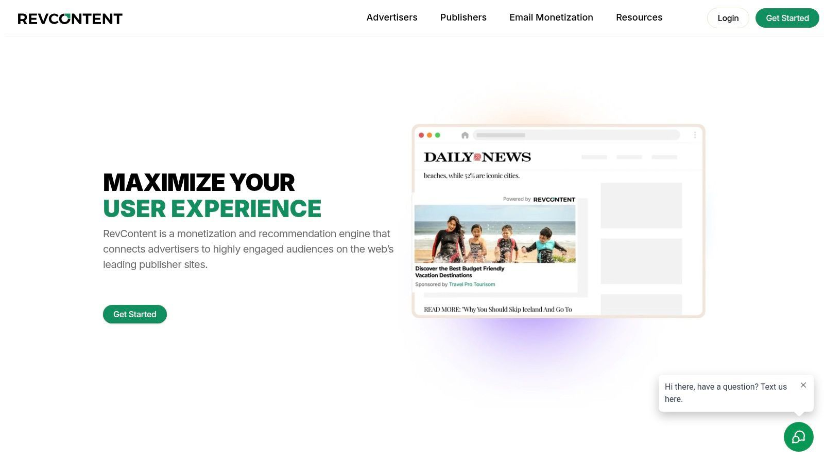
The platform operates primarily on a CPC model, which is ideal for affiliates who want to pay only when a user engages with their ad. Its strength lies in its ability to scale campaigns across a wide network of U.S. content sites, offering a different type of traffic compared to search-based platforms. For an affiliate marketer, Revcontent is excellent for promoting offers that require more context or a softer sell, often using pre-landers to warm up traffic before sending it to the final affiliate link. This makes it a popular choice in the pay per click advertising affiliate program landscape.

Key Features and Considerations
- Bidding and Budgets: Supports CPC and vCPM bid types, giving affiliates direct control over their ad spend with straightforward daily budget settings.
- Targeting Controls: Provides essential targeting options, including geographic location, device type, and the ability to blacklist specific publisher placements to refine traffic quality.
- Onboarding: Features a self-serve platform with a relatively simple campaign setup process and transparent reporting on budget consumption and performance.
Website: https://www.revcontent.com

8. Media.net
Media.net serves as a powerful alternative and complement to Google's Display Network, specializing in contextual and native advertising. Its core strength is its direct access to the vast pool of search demand from the Yahoo! Bing Network, allowing affiliates to place highly relevant ads on publisher websites. This makes it an excellent choice for promoting affiliate offers on content-rich landing pages and blogs where contextual relevance drives clicks and conversions.

For affiliates, Media.net's technology automatically scans your content to serve ads that align with the page's topic, which can lead to higher engagement rates compared to less targeted display ads. This platform is particularly effective for those who operate brand-safe affiliate sites and want to monetize their traffic without disrupting the user experience. By leveraging this contextual intelligence, you can effectively run a pay per click advertising affiliate program that feels native to your content.

Key Features and Considerations
- Ad Formats: Specializes in contextual, native, and display ad units that blend seamlessly with website content for a less intrusive user experience.
- Demand Source: Provides exclusive access to premium search demand from the Yahoo! Bing Network, tapping into a different segment of the search market.
- Contextual Targeting: The platform's algorithm analyzes page content to deliver highly relevant ads, which is ideal for niche affiliate sites.
Website: https://www.media.net

9. PropellerAds
PropellerAds is a large self-serve advertising network known for its versatility and accessibility, making it a popular choice for affiliates looking to launch campaigns quickly. Its primary strength is the wide range of ad formats, including push notifications, in-page push, pop-unders, and display ads, all available on a CPC, CPM, or CPA basis. This variety allows marketers to test different approaches and find what resonates best with their target audience without a significant upfront commitment.
The platform is particularly affiliate-friendly due to its low minimum deposit, which starts at around $100 depending on the payment method. This low barrier to entry empowers affiliates to experiment with different offers and GEOs, making it an excellent part of any pay per click advertising affiliate program strategy focused on rapid testing and scaling. The platform's global reach ensures that successful campaigns can be quickly expanded to new markets.

Key Features and Considerations
- Ad Formats: Supports a diverse mix including Push, In-Page Push, Pop, and traditional Display ads, catering to various affiliate marketing styles.
- Targeting Options: Offers standard targeting by GEO, device, OS, and browser, alongside more advanced features like demographic and interest targeting on certain formats.
- Affiliate-Centric Features: Includes a "Priority Program" that rewards higher-spending advertisers with dedicated account managers and other perks, plus 24/7 support for all users.
Website: https://propellerads.com

10. Adsterra
Adsterra is a well-known performance ad network that offers a diverse range of ad formats beyond traditional search and display, making it a popular choice for affiliates exploring alternative traffic sources. Its strength lies in its portfolio of high-engagement formats like push notifications, pop-unders, and its unique "Social Bar," which are well-suited for direct-response affiliate offers. Affiliates can tap into a global inventory across various verticals, often finding less competitive pockets of traffic compared to major search engines.
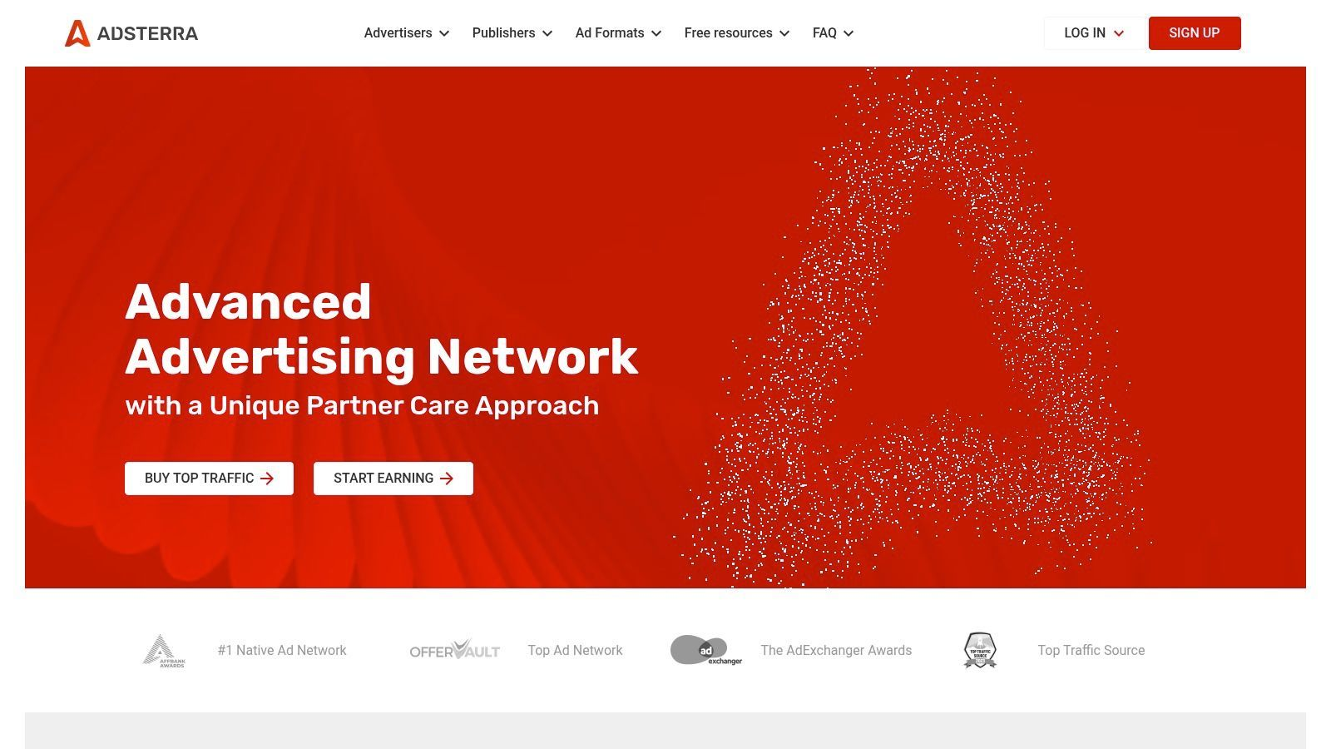
The self-serve platform is designed for quick campaign launches, which is ideal for affiliates who want to test new offers and funnels rapidly. With support for CPC, CPM, and CPA pricing models, you can align your campaign's financial structure directly with your affiliate payout model. The network’s flexibility and accessible entry point make it a strong contender in any pay per click advertising affiliate program strategy, especially for those in verticals like gaming, utilities, or lead generation.

Key Features and Considerations
- Diverse Ad Formats: Specializes in push, in-page push, pop-under, native, and banner ads, providing multiple avenues to reach target audiences.
- Accessible Platform: Features a user-friendly self-serve dashboard with fast campaign approvals and S2S postback integration for accurate tracking.
- Low Entry Barrier: Minimum deposit requirements are often around $100, allowing affiliates to test the platform without a significant upfront investment.
Website: https://adsterra.com

11. Zeropark
Zeropark is a self-serve traffic platform specializing in commerce-media inventory, making it a strong contender for affiliates focused on arbitrage, couponing, and search-style placements. It provides a unique opportunity to tap into buyer-intent traffic sources that are often less saturated than major search engines. This makes Zeropark a valuable tool for affiliates looking to diversify their traffic streams beyond traditional PPC platforms.
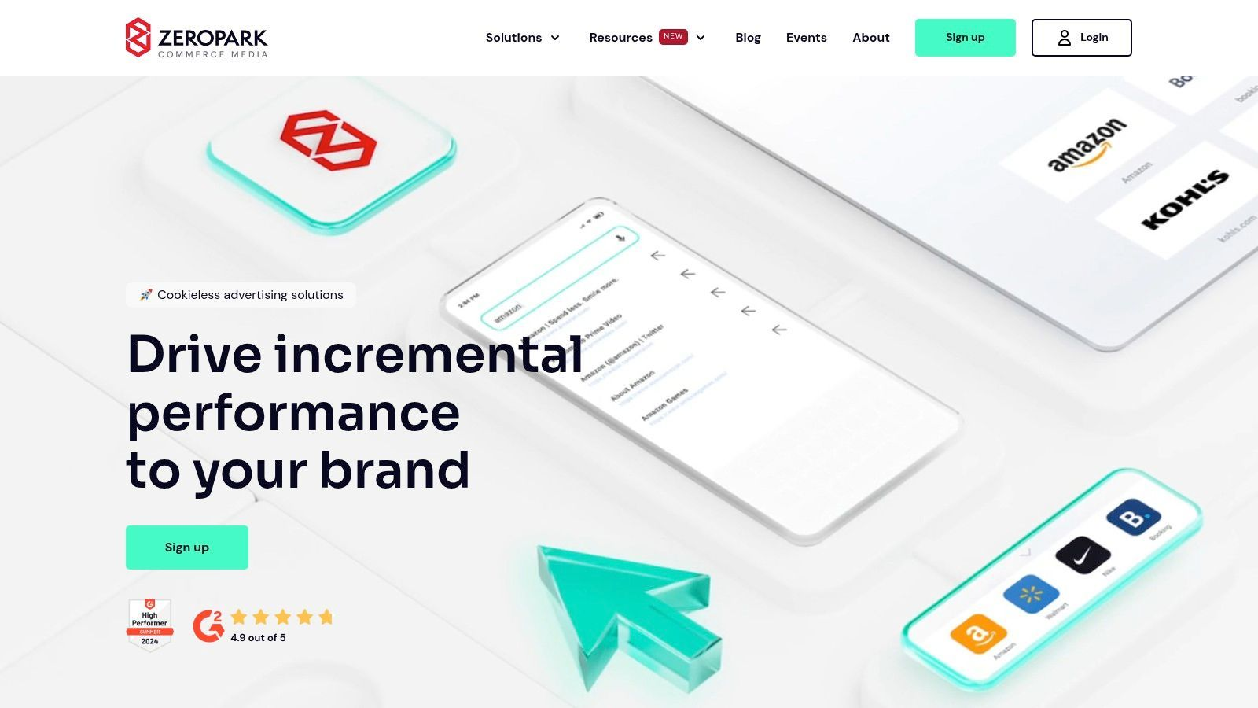
The platform is designed to give advertisers direct control over their campaigns, offering a variety of ad formats suitable for different affiliate marketing strategies. Its clear funding policies and tools, like the traffic calculator, empower marketers to make informed decisions before launching. This level of transparency and control is particularly beneficial for those running a sophisticated pay per click advertising affiliate program where every cent of ROI counts.

Key Features and Considerations
- Bidding and Targeting: Offers CPC bidding with essential optimization features like whitelists/blacklists and granular targeting by device and carrier.
- Optimization Tools: Provides a traffic calculator and marketplace optimization tools to help affiliates forecast potential and refine campaigns for better performance.
- Support: Access to a dedicated account manager is available for advertisers who reach higher spending thresholds, offering personalized strategic guidance.
Website: https://zeropark.com

12. BidVertiser
BidVertiser has been a long-standing self-serve ad network, offering a low-cost entry point for affiliate marketers looking to experiment with various ad formats. Its main appeal lies in its simplicity and accessibility, making it a viable option for testing new offers or exploring less competitive GEOs without a significant upfront investment. It provides a mix of native, banner, pop, and direct ad formats, allowing affiliates to diversify their traffic sources beyond the major search engines.
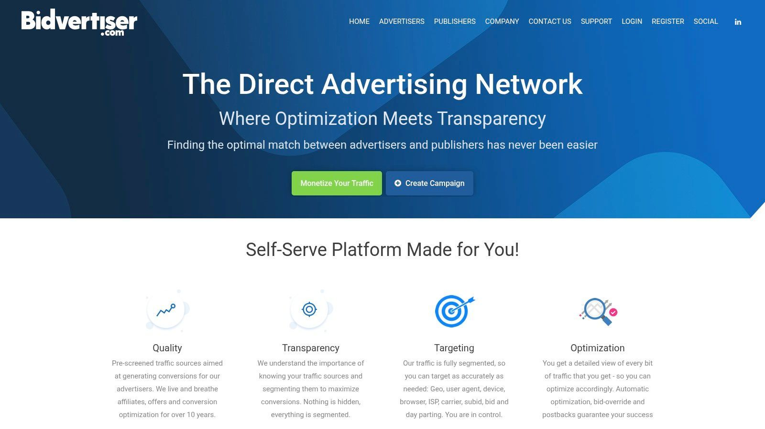
The platform is particularly useful for those on a tight budget or those new to media buying. While it may not have the premium inventory of larger networks, it can be a valuable tool for finding profitable pockets of traffic for certain affiliate campaigns. The straightforward campaign setup and A/B testing capabilities allow for quick deployment and iteration, which is ideal for rapidly validating angles for your pay per click advertising affiliate program offers.

Key Features and Considerations
- Campaign Types: Supports a diverse range of ad formats including native ads, display banners, pop-unders, and direct link traffic.
- Bidding Model: Primarily operates on a CPC model but also offers hybrid CPA options, giving affiliates some flexibility in optimizing for performance.
- Targeting: Provides standard targeting options such as GEO, device, browser, and contextual categories, suitable for broad-to-medium focused campaigns.
Website: https://www.bidvertiser.com

Top 12 PPC Affiliate Networks Comparison
Platform | Core Features | Quality (★) | Price / Value (💰) | Target Audience (👥) | Unique Selling Points (✨ / 🏆)
Google Ads | Search, YouTube, Display, Shopping, Performance Max | ★★★★★ | 💰 Flexible budgets; often higher CPCs in competitive niches | 👥 Performance marketers & high-intent advertisers | ✨ Best intent reach & smart bidding; 🏆 top commercial intent
Microsoft Advertising | Bing + syndication, Shopping, LinkedIn-profile targeting, Google import | ★★★★ | 💰 Often lower CPCs vs Google; variable thresholds | 👥 B2B, desktop-heavy advertisers & budget-conscious teams | ✨ Lower competition & strong desktop reach
TikTok Ads | Short-video auction, Pixel/API, Spark Ads, creative tools | ★★★★ | 💰 Efficient CPCs; common mins (campaign ≥ $50/day) | 👥 Creators, DTC, mobile apps & social commerce | ✨ Fast creative testing; strong viral/social reach
Taboola | Native content discovery on premium publishers, AI recommendations | ★★★ | 💰 CPC/CPM; CPCs can rise on Tier-1 inventory | 👥 Top-of-funnel advertisers, advertorial/long-form funnels | ✨ Massive US publisher reach; good for pre-landers
Outbrain | Native CPC, section-level controls, conversion bidding | ★★★★ | 💰 Typically higher CPCs on premium inventory | 👥 Brand-safe native advertisers & content marketers | ✨ Granular time/section CPC controls; 🏆 premium placements
MGID | Native CPC, self-serve, global GEO/device targeting | ★★★ | 💰 Entry promos & flexible CPC ranges | 👥 Affiliates testing GEOs & content funnels | ✨ Global reach with promotional entry offers
Revcontent | CPC/vCPM, publisher controls, daily budgets | ★★★ | 💰 Low minimums; competitive CPCs for native | 👥 Aggressive testers scaling native traffic | ✨ Quick approvals and strong optimization levers
Media.net | Contextual/native tied to Yahoo/Bing demand, header bidding | ★★★★ | 💰 Premium contextual placements; scale varies by niche | 👥 Brand-safe affiliate landing content & contextual advertisers | ✨ Access to premium search demand via Yahoo/Bing
PropellerAds | Push, in-page push, pop, display; CPC/CPM/CPA | ★★★ | 💰 Low starting deposit (~$100); many formats | 👥 Affiliate testers needing fast, low-cost trials | ✨ Wide format mix and quick scaling options
Adsterra | Push, interstitials, pop, native, S2S postback, promos | ★★★ | 💰 Low deposits (~$100) and frequent promos | 👥 Direct-response affiliates & traffic testers | ✨ S2S integrations and fast approvals
Zeropark | CPC/CPV commerce-media, whitelists/blacklists, tools | ★★★★ | 💰 Transparent minimums; initial ≈ $200 | 👥 Affiliate arbitrage, commerce/search advertisers | ✨ Granular marketplace tools & buyer-intent inventory
BidVertiser | CPC, native/banner/pop, simple campaign setup | ★★ | 💰 Low barrier; modest deposit for beginners | 👥 Small tests, niche GEOs, beginners | ✨ Easy setup, direct link/XML feeds for quick tests

Final Verdict: Choosing Your Next PPC Platform
Navigating the landscape of pay per click advertising affiliate programs can feel overwhelming, but as we've detailed, the key is aligning your choice with your unique strategy. The perfect platform isn't a one-size-fits-all solution; it's the one that best matches your target audience, vertical, budget, and risk tolerance. Your decision hinges on a strategic trade-off between traffic quality, cost, and compliance complexity.
The giants, Google Ads and Microsoft Advertising, offer unparalleled access to high-intent users actively searching for solutions. They are the gold standard for bottom-of-the-funnel conversions but come with the highest costs and most stringent policies. Success here requires a sophisticated approach to keyword research, ad copy, and landing page optimization. On the other hand, platforms like TikTok Ads provide massive, engaged audiences but demand creative, platform-native content that feels authentic, not overtly promotional.

Matching the Platform to Your Purpose
For those aiming for broad, top-of-funnel brand awareness and lead generation through content, native advertising is a powerful channel. Networks like Taboola, Outbrain, and MGID are designed to place your affiliate offers in a contextually relevant, non-disruptive way. This approach is ideal for verticals like health, finance, and software, where educating the user is part of the conversion path.
If you're an affiliate marketer who thrives on agility, rapid testing, and diverse ad formats, networks like PropellerAds, Adsterra, and Zeropark offer a compelling alternative. With lower entry barriers and a wide range of targeting options, including push notifications and pop-unders, these platforms are excellent for testing new offers and scaling campaigns quickly in less competitive niches. They provide the flexibility needed to find profitable pockets of traffic without the massive upfront investment required by search giants.

The Strategic Blueprint for Success
Your journey doesn't end with selecting a platform. The real work begins with implementation, and a successful pay per click advertising affiliate program campaign is built on a foundation of meticulous tracking, testing, and optimization.
Here are the critical takeaways to guide your next steps:
- Start with a Compliance-First Mindset: Before you spend a single dollar, thoroughly read the advertising policies of your chosen platform. Understand their stance on affiliate links, redirects, and the specific claims you can make for your vertical. Ignoring this step is the fastest way to get your ad account suspended.
- Segment and Test Everything: Never assume what will work. Test different ad formats, headlines, creative assets, landing pages, and calls to action. Use the platform’s tracking pixels to gather data and isolate the variables that drive conversions.
- Master Your Tracking: Your affiliate success is directly tied to the quality of your data. Implementing robust tracking is non-negotiable. This is where cloaking and link management tools become essential, allowing you to protect your affiliate links, route traffic based on geo or device, and perform sophisticated split tests without violating platform terms.
- Scale Methodically: Once you identify a winning combination of offer, creative, and targeting, don't rush to scale. Increase your budget gradually while monitoring your key performance indicators (KPIs) like click-through rate (CTR), conversion rate, and return on ad spend (ROAS). Scaling too quickly can disrupt the algorithm and tank your campaign's performance.
Ultimately, choosing the right pay per click advertising affiliate program is a strategic process of elimination and experimentation. Use this guide to create a shortlist, launch small pilot campaigns, and let the data guide your decisions. The most profitable traffic sources are waiting for those willing to test, learn, and adapt.
Ready to protect your campaigns and unlock advanced tracking capabilities across any PPC platform? AliasLinks gives you the power to cloak your links, split-test landing pages, and manage your traffic with precision, ensuring better compliance and higher ROI. Start your free trial at AliasLinks today and take control of your affiliate marketing.

